Zoom User Guide

Hayden Quinn

2023-10-13

# Overview

This User guide is designed to support students in installing, running and effectively utilising Zoom for their classes.

Zoom is a cloud-based video conferencing platform that can be used for video conferencing meetings, audio conferencing, webinars, meeting recordings, and live chat. Zoom technology puts people at the centre, enabling meaningful connections, facilitating modern collaboration, and driving human innovation. Founded in 2011, Zoom is publicly traded and headquartered in San Jose, California.

Contents

Overview 2

Figures 4

Minimum hardware and software requirements 5

Safe use 6

Installation 7

Getting started 9

Major features and functions 11

Error messages and troubleshooting 12

developer contact information 13

Version control and approval 14

# Figures

Figure 1 Download the Zoom desktop client 7

Figure 2 Download Zoom on iOS. 7

Figure 3 Download Zoom on Android. 8

# Minimum hardware and software requirements

**System Requirements**

An internet connection – broadband wired or wireless (3G or 4G/LTE)

* Speakers and a microphone – built-in, USB plug-in, or wireless Bluetooth
* A webcam or HD webcam - built-in, USB plug-in, or:
  + An HD cam or HD camcorder with a video-capture card  
    **Note**: See the list of [supported devices](https://support.zoom.us/hc/en-us/articles/360026690212).
  + Virtual camera software for use with broadcasting software like OBS or IP cameras  
    **Note**: For macOS, [Zoom client 5.1.1 or higher is required](https://support.zoom.us/hc/en-us/articles/360044801671).

**Supported Operating Systems**

* macOS X with macOS X (10.11) or later
* Windows 11
* Windows 10  
  **Note**: Devices running Windows 10 must run Windows 10 Home, Pro, or Enterprise. S Mode is not supported.
* Windows 8 or 8.1
* Windows 7
* Ubuntu 12.04 or higher
* Mint 17.1 or higher
* Red Hat Enterprise Linux 8.0 or higher
* Oracle Linux 8.0 or higher
* CentOS 8 or higher
* Fedora 21 or higher
* OpenSUSE 13.2 or higher
* ArchLinux (64-bit only)

# Safe use

* Encrypted meetings on by default.
* Create Waiting Rooms.
* Require host to be present before meeting starts.
* Expel participants.
* Suspend participant activities.
* Lock a meeting.
* Screen share watermarks.
* Audio signatures.
* Enable/disable participants to record.
* Temporary pause screen-sharing.
* Use a passcode.
* Only allow individuals with a given email domain to join.

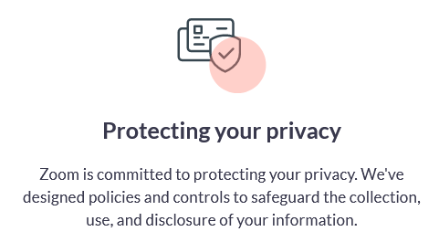

* Encryption for video, audio, and screen-sharing.
* Advanced chat encryption.
* Zoom phone voicemail cloud storage.
* Recordings stored locally or in cloud.
* Audio signature to prevent unauthorized sharing.
* Screenshot watermarks.

# Installation

**To download the Zoom desktop client**:

Figure Download the Zoom desktop client

**To download the Zoom mobile app for iOS**:

Figure Download Zoom on iOS.

**To download the Zoom mobile app for Android**:

Figure Download Zoom on Android.

# Getting started

1. 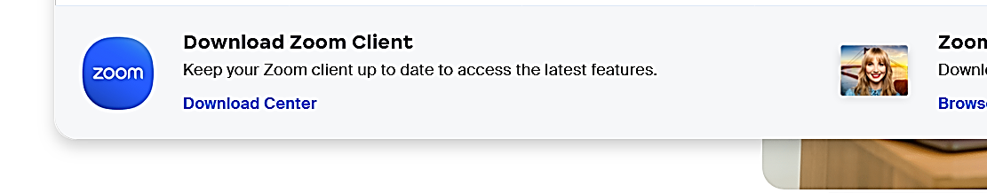Download and Install Zoom: Go to the app store and download Zoom or visit the [Zoom website](https://zoom.us/), go to “Resources”, and download the software.

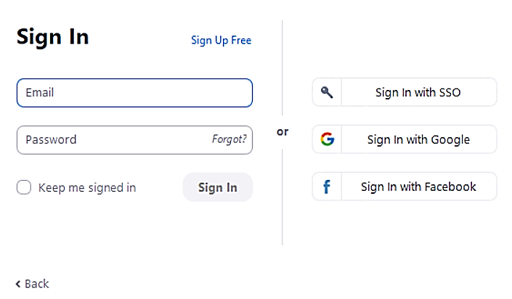

1. Sign Up or Log in: Create a new Zoom account or log in with your existing credentials.

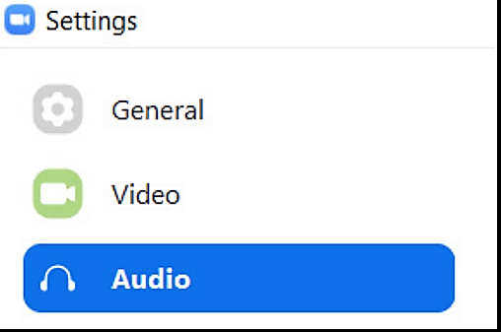

1. Adjust Audio and Video Settings: Before joining a meeting, make sure your microphone and camera are working properly. Go to “Settings” and test your audio and video devices.

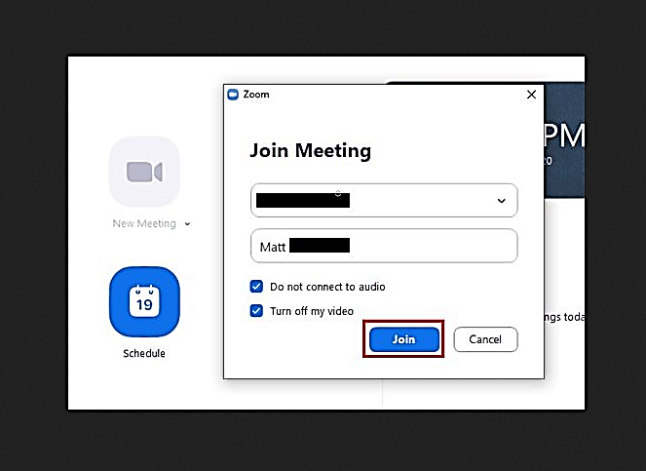

1. Schedule or Join a Meeting: To schedule a meeting, click “Schedule” and enter the details like date, time, and topic or click “Join” to enter a meeting ID provided by the host.
2. 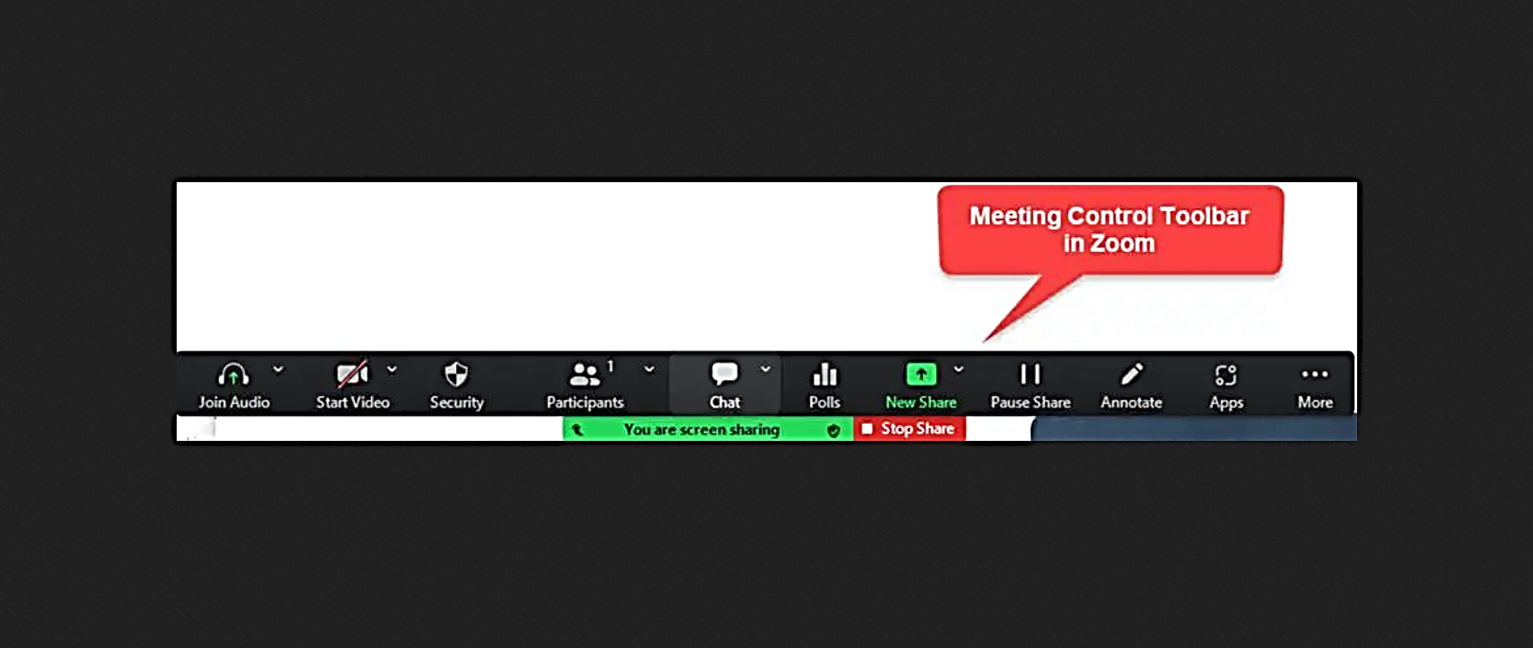Explore Meeting Controls: Familiarize yourself with the various meeting controls, such as mute/unmute, screen sharing, and chat.
3. 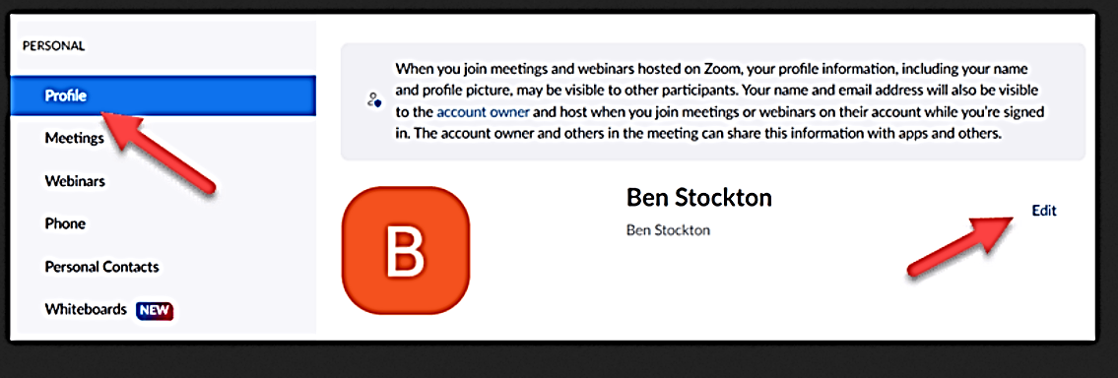Customise Your Profile: Add a profile picture by clicking on your initials or profile icon. Update your display name by going to “Settings” > “Profile.”
4. 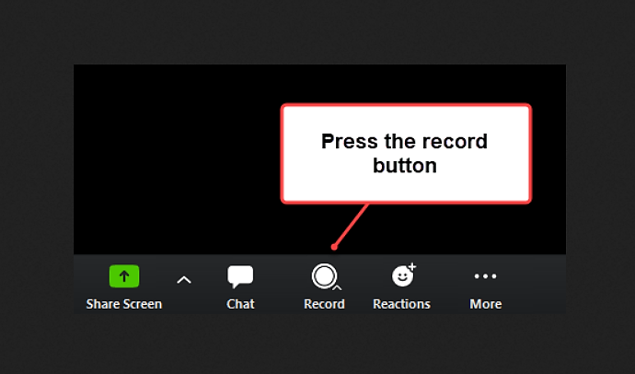Record Meetings (Optional): If needed, you can record meetings for future reference. During a meeting, click on the “Record” button, and it will save to your local device.

# Major features and functions

**Video Conferencing:** Host or join video meetings with multiple participants.

**Screen Sharing:** Share your screen with others for presentations or collaboration.

**Chat and Messaging:** Send messages, files, and links during or in between meetings.

**Recording:** Record meetings for future reference or for those who couldn’t attend.

**Virtual Backgrounds:** Customize your video background with fun or professional images.

**Breakout Rooms:** Split meeting participants into smaller groups for discussions or activities.

# Error messages and troubleshooting

|  |  |  |
| --- | --- | --- |
| Description | Error Code | Suggestion |
| Failed to create a data connection with our server. | 5 | Please check your network connection or network configuration. |
| Failed to send create meeting command to our server. | 15 | Please check your network or HTTP request configuration. |
| SDK authentication failure: invalid SDK key & secret | 3023 | Please check your SDK key & secret |
| Your account does not support using SDK | 3024 | Ensure your license type or your account has SDK enabled. |
| No response from our server in 30 seconds | 5003 | Please try again later. If it happens a lot, please visit our community forum for help. |
| DNS resolve failure | 5004 | Please check your network adaptor or your network hardware. |
| Conference does not exist | 102006 | Ensure the conference number is correct or has successfully been scheduled/hosted. |
| Zoom client version lower than the minimum required version | 102011 | Please download our latest version of SDK |
| Zoom client version higher than the maximum allowed version | 102012 | Please download our latest version of SDK |
| Conference token expired | 102014 | |  |  | | --- | --- | |  | Get a new token from our API | |
| Server is too busy | 103008 | Please try again later. If it happens a lot, please visit our community forum for help. |
| Your account does not support the requested feature | 103024 | Please ensure your account has the feature that you are requesting. |
| Your account does not support call out | 103025 | Please ensure your account supports call out feature. |
| Your account is in blacklist | 103039 | Please seek support since your account is in the blacklist. |
| Conference going to create already exist | 102004 / 103001 | Please try another meeting number or your previous “create meeting” request was successful. |
| Number of attendees has reached limitation | 102010 / 103006 | |  |  | | --- | --- | |  | Contact our sales engineer if you would like to have more attendees. | |
| The conference you are joining is locked | 102015 / 103011 | Please contact your meeting host to unlock the meeting. |
| Account is restricted, not allowed to join the conference | 102016 / 103014 | Your account is restricted, please seek support. |

**For a complete list of Error Codes, please visit the** [**Zoom Website**](https://developers.zoom.us/docs/meeting-sdk/android/resource/error-codes/)**.**

# Developer Contact Information

**General Support:** Get support from Zoom’s chatbot if you have a free account. If you have a question and you need answers right away, start an instant message with Zoom’s chatbot on the Zoom website. You’ll be chatting with a computer, not an actual person, so ask it short, direct questions to get the most benefit. You can use this feature if you have a free account, a licensed/pro account, or a business account.

To connect with the chatbot, head to <https://support.zoom.us/hc/en-us/articles/201362003> then click on chatbot.

**Non-Urgent Questions:** If you’d like to email Zoom instead, you can send them a message from your personal email account to [info@zoom.us](mailto:info@zoom.us). Make sure you give them your Zoom ID and describe the problem as accurately as possible. You can email Zoom no matter what kind of account you have.

**For Developer:** Email [developer-support@zoom.us](mailto:developer-support@zoom.us) for any inquiries or assistance related to development.

**For Business Owners and administration:** Call +61.1800.768.027 (Australian Headquarters).  
Other headquarter offices can be reached at:   
San Jose: 1-888-799-9666  
France: +33.800.94.64.64  
India: 000.800.050.2040  
Japan: +81.053.132.0070  
New Zealand: +64.800.475.039  
Singapore: +65.800.321.1249  
United Kingdom: +44.800.368.7314 or +44.20.7039.8961

**Submit a help request online if you’re a licensed or pro user:** You can fill out the support form by visiting <https://support.zoom.us/hc/en-us/requests/new>.

**Contact Sales Team:** You can fill out the sales contact form by visiting <https://zoom.us/contactsales>.

**Visit** [**https://www.zoom.com/en/contact/**](https://www.zoom.com/en/contact/) **for more contact information.**

# Version Control and Approval